Name : Tahir Fareed

Roll no : SU92-BSAIM-F24-036

Program : BSAI ( 4-A)
HADITH QnA BOT
Documentation
PAI Lab 12
────────────────────────────────────────────────────────────
Pipeline Overview
Git Clone → Load CSVs → Clean → MiniLM Embed → FAISS Index → Flask UI

1. Project Overview
The Hadith QnA Bot is an intelligent question-answering system built on a curated collection of Islamic Hadith literature. The system leverages state-of-the-art natural language processing (NLP) techniques to allow users to search and retrieve relevant Hadith passages using natural language queries.
This project was developed as part of PAI (Practical Artificial Intelligence) Lab 12, Task 2, and demonstrates a complete end-to-end NLP pipeline from raw data ingestion to an interactive web-based user interface.
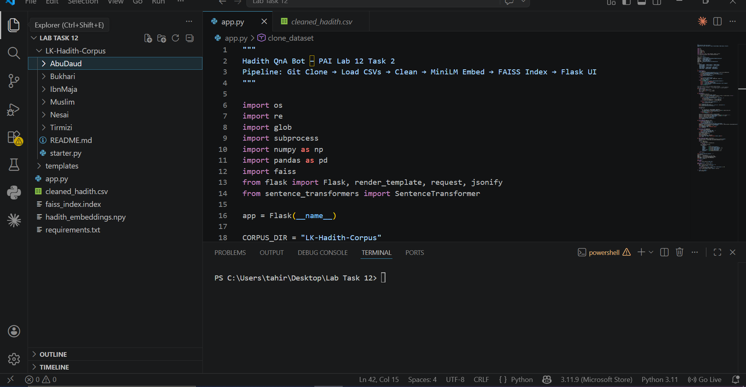

1.1 Objectives
- Clone and process the LK-Hadith-Corpus dataset from a remote Git repository
- Clean and preprocess CSV-formatted Hadith data across multiple books and chapters
- Generate semantic embeddings using the MiniLM sentence transformer model
- Build a FAISS (Facebook AI Similarity Search) index for fast nearest-neighbor retrieval
- Expose a Flask-based REST API and web UI for interactive question answering

1.2 Technology Stack
Category | Technology | Purpose
Language | Python 3.x | Core application logic
Web Framework | Flask | REST API and UI server
NLP / Embeddings | sentence-transformers (MiniLM) | Semantic vector generation
Vector Search | FAISS | Fast similarity search
Data Processing | Pandas, NumPy | CSV parsing, data manipulation
Dataset | LK-Hadith-Corpus | Source Hadith data (CSV format)

2. Project Structure
The project follows a well-organized directory structure. Below is an overview of each component:

2.1 Directory Layout
LAB TASK 12/
LK-Hadith-Corpus/ # Cloned Hadith dataset
AbuDaud/ # Chapters 36–43 (CSV files)
Bukhari/ # Bukhari Hadith collection
IbnMaja/ # Ibn Maja collection
Muslim/ # Muslim collection
Nesai/ # Nesai collection
Tirmizi/ # Tirmizi collection
templates/ # Flask HTML templates (Jinja2)
app.py # Main Flask application
cleaned_hadith.csv # Preprocessed merged dataset
faiss_index.index # Serialized FAISS vector index
hadith_embeddings.npy # NumPy embeddings array
starter.py # Pipeline bootstrap script
requirements.txt # Python dependencies
README.md # Project readme

2.2 File Descriptions
File / Folder | Description
app.py | Main application entry point. Defines Flask routes, loads the FAISS index, handles user queries, and renders the web interface.
starter.py | Bootstrap script that clones the dataset, processes CSVs, generates embeddings, and builds the FAISS index.
cleaned_hadith.csv | The merged and preprocessed Hadith dataset. Contains cleaned text entries from all six Hadith books.
faiss_index.index | Serialized FAISS index file containing the vector representations of all Hadith entries for fast similarity search.
hadith_embeddings.npy | NumPy array file storing pre-computed MiniLM sentence embeddings for each Hadith entry.
requirements.txt | Lists all Python package dependencies required to run the application.
LK-Hadith-Corpus/ | Root directory of the cloned Hadith corpus. Contains sub-folders for each Hadith book, each holding numbered chapter CSV files.
templates/ | Contains Jinja2 HTML templates used by Flask to render the web user interface.

3. Data Pipeline
The application follows a clearly defined, sequential data pipeline. Each stage transforms the data from its raw form into a searchable semantic index. The pipeline consists of six major stages:

3.1 Stage 1 – Git Clone
The pipeline begins by programmatically cloning the LK-Hadith-Corpus repository from a remote source using Python’s subprocess module. This ensures the dataset is always fetched fresh from the source.

import subprocess
subprocess.run(['git', 'clone', <REPO_URL>, CORPUS_DIR])
This approach makes the system reproducible and portable across different machines.

3.2 Stage 2 – Load CSVs
Once cloned, the pipeline uses Python’s glob module to recursively discover all CSV files within the corpus directory. All chapter files across all six Hadith books are loaded and merged into a single Pandas DataFrame.
import glob, pandas as pd
files = glob.glob(CORPUS_DIR + '/**/*.csv', recursive=True)
df = pd.concat([pd.read_csv(f) for f in files])

3.3 Stage 3 – Clean
The raw CSV data undergoes several preprocessing steps to ensure data quality:
- Removal of null and duplicate entries
- Regex-based text normalization using Python’s re module
- Stripping of special characters, extra whitespace, and unwanted symbols
- Standardization of text encoding
The cleaned dataset is saved to cleaned_hadith.csv for reuse, avoiding redundant processing on subsequent runs.

3.4 Stage 4 – MiniLM Embed
Each cleaned Hadith text is passed through the sentence-transformers library using the all-MiniLM-L6-v2 model to generate dense semantic vector embeddings. These 384-dimensional vectors capture the semantic meaning of each Hadith.

from sentence_transformers import SentenceTransformer
model = SentenceTransformer('all-MiniLM-L6-v2')
embeddings = model.encode(hadith_texts)

Embeddings are persisted to hadith_embeddings.npy using NumPy, so they do not need to be recomputed on every application start.

3.5 Stage 5 – FAISS Index
The generated embeddings are used to build a FAISS (Facebook AI Similarity Search) flat index. FAISS enables sub-second nearest-neighbor lookup across tens of thousands of vectors.

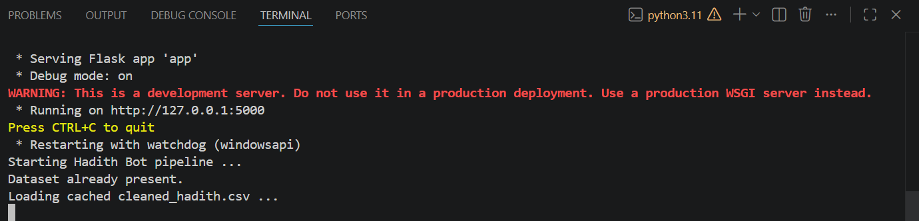

import faiss
index = faiss.IndexFlatL2(embedding_dim)
index.add(embeddings)
faiss.write_index(index, 'faiss_index.index')
The index is serialized to disk as faiss_index.index and loaded at application startup.

3.6 Stage 6 – Flask UI
The final stage exposes the search functionality via a Flask web application. The server loads the FAISS index and embeddings at startup, and serves a web UI that allows users to submit natural language queries. Query text is embedded using the same MiniLM model, and the FAISS index returns the top-k most semantically similar Hadith entries.

from flask import Flask, render_template, request, jsonify
app = Flask(__name__)
@app.route('/search', methods=['POST'])
def search(): ...

GUI interface :
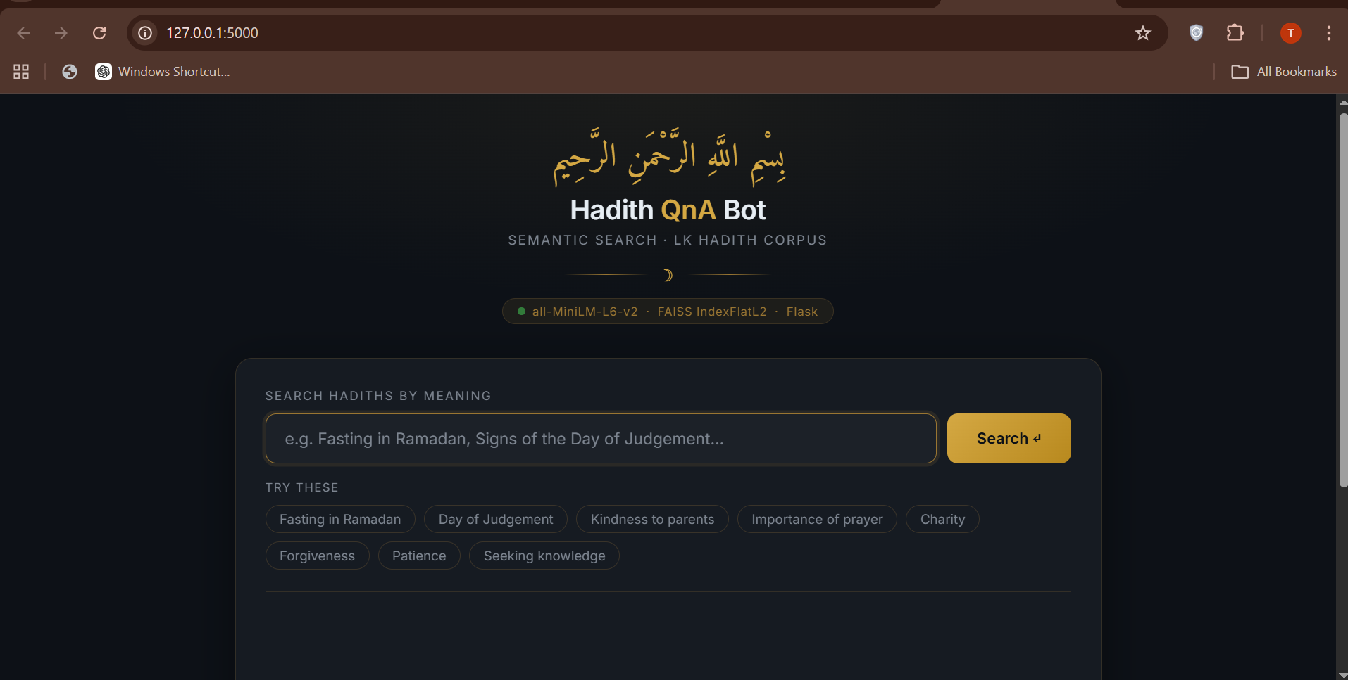

4. Dataset – LK-Hadith-Corpus
The LK-Hadith-Corpus is an open-source collection of authenticated Hadith literature sourced from six major canonical Hadith books of Sunni Islam. The dataset is structured as CSV files, organized by book and chapter.

4.1 Included Books
Book Name | Folder | Notes
Abu Dawud | AbuDaud/ | Chapters 36–43 included
Sahih Bukhari | Bukhari/ | Complete collection
Ibn Maja | IbnMaja/ | Complete collection
Sahih Muslim | Muslim/ | Complete collection
Sunan Nesai | Nesai/ | Complete collection
Jami Tirmizi | Tirmizi/ | Complete collection

4.2 CSV Format
Each chapter is stored as an individual CSV file named ChapterN.csv. The CSV files contain structured fields including the Hadith text, narrator chain (isnad), reference numbers, and book metadata.

5. Key Python Modules

5.1 Import Summary
The application uses the following Python standard library and third-party modules:
Module | Type | Usage
os | Standard Library | File system path operations and environment variables
re | Standard Library | Regular expressions for text cleaning and normalization
glob | Standard Library | Recursive discovery of CSV files in the corpus directory
subprocess | Standard Library | Programmatic execution of git clone command
numpy (np) | Third-Party | Array operations, saving/loading .npy embedding files
pandas (pd) | Third-Party | CSV loading, DataFrame manipulation, data cleaning
faiss | Third-Party | Building and querying the vector similarity index
flask | Third-Party | Web server, routing, JSON API, and HTML templating
sentence_transformers | Third-Party | Loading MiniLM model and encoding text into embeddings

6. Setup and Installation

6.1 Prerequisites
- Python 3.8 or higher
- pip package manager
- Git installed and accessible from the command line
- Minimum 4GB RAM recommended (for embedding generation)

6.2 Installation Steps
- Clone or download this project to your local machine.
- Open a terminal and navigate to the project directory.
- Install all Python dependencies:
pip install -r requirements.txt
- Run the starter script to clone the corpus, clean data, and build the FAISS index:
python starter.py
- Launch the Flask application:
python app.py
- Open a browser and navigate to http://127.0.0.1:5000 to access the web UI.

6.3 requirements.txt
The following packages are required and should be listed in requirements.txt:
flask
pandas
numpy
faiss-cpu
sentence-transformers

7. How It Works – Query Flow
When a user submits a query through the web interface, the following steps occur:
- The user enters a natural language question (e.g., 'What does Islam say about cleanliness?').
- Flask receives the POST request and extracts the query string.
- The query is passed to the MiniLM model, which generates a 384-dimensional embedding vector.
- The embedding is used to query the FAISS index, which returns the indices of the top-k most similar Hadith entries.
- The corresponding Hadith texts are retrieved from the cleaned DataFrame and returned as a JSON response.
- The Jinja2 template renders the results in the browser with book, chapter, and text details.

8. Conclusion
The Hadith QnA Bot successfully demonstrates how modern NLP techniques can be applied to classical Islamic literature to create a powerful and accessible search tool. By combining MiniLM semantic embeddings with FAISS vector indexing and a Flask-based interface, the system provides fast, semantically accurate Hadith retrieval without relying on simple keyword matching.
This project serves as a practical example of building an end-to-end AI-powered information retrieval system using Python and open-source libraries. It can be extended in future work to support multilingual queries, re-ranking with a cross-encoder, or deployment to a cloud platform.

End of Document

